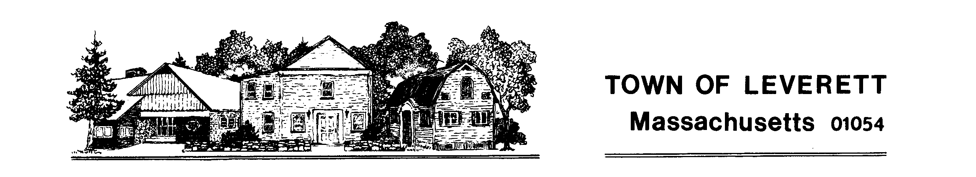

Legal Advertisement

Town of Leverett
Invitation for Bids
Public Safety Complex and Library Parking Lots Paving

The Town of Leverett is seeking bids for the final grading and paving of the municipal parking lots located at 75 and 95 Montague Road in Leverett. Bid documents and specifications are available by emailing townadministrator@leverett.ma.us. Sealed bids, plainly marked "PSC and Library Parking Areas Paving” will be accepted until May 1, 2024 at 12:00 PM.

There will be a mandatory pre-bid meeting on Friday, April 19th at 10:00 am beginning in the parking lot at 95 Montague Road.

The contract will be awarded based on the estimated quantities provided times the price submitted. The vendor whose total is lowest for the combination of all items will be awarded unless the Town has a legitimate reason to not award to the low bidder.

The Town of Leverett reserves the right to reject any and all bids in whole or in part, and to waive irregularities and informalities, when at its sole discretion it is deemed to be in the best interest of the Town and to the extent permitted by law.

Marjorie McGinnis, Administrator
413-548-9699
townadministrator@leverett.ma.us
April 11, 2024

