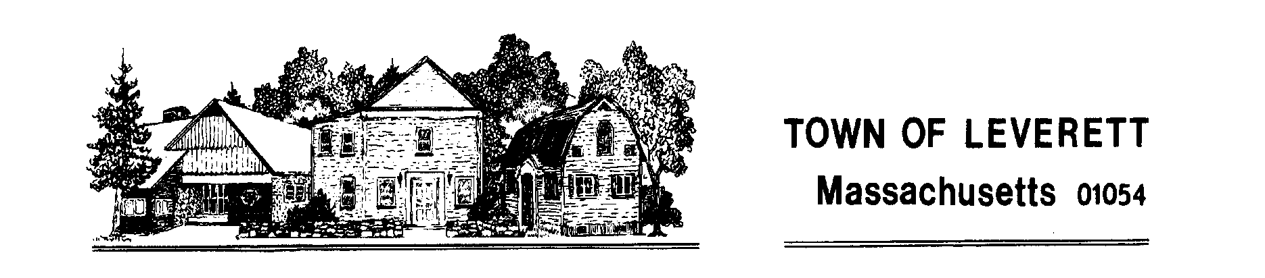

**TOWN OF LEVERETT**

**RATTLESNAKE GUTTER** **CONSERVATION AREA DRAINAGE IMPROVEMENT AND RETAINING WALL RECONSTRUCTION**

**INVITATION FOR BIDS**

The Town of Leverett will accept sealed bids for drainage repair and retaining wall reconstruction on the discontinued section of Rattlesnake Gutter Road, which is now the Rattlesnake Gutter Conservation Area.

Complete specifications and bidding documents are available from the Administrator at

townadministrator@leverett.ma.us.

**Sealed bids, plainly marked "Rattlesnake Gutter Conservation Area Drainage and Retaining Wall Repair"** will be received by Marjorie McGinnis, Administrator at 9 Montague Road, Leverett, MA 01054 until **July 25th, 2025 at 2:00 pm**, at which time they will be publicly opened and read aloud.

A **mandatory** **pre-bid site visit is set for July 11th, 2025 at 10:00 am** at the site.

Bid is subject to prevailing wage rates as per MGL Chapter 149, Section 26 - 27f inclusive.

The Town of Leverett reserves the right to accept or reject any or all bids in total or in part as they may deem to be in their best public interest.

Date: June 30, 2025