Preliminary Annual Survey Results – 2017-2020
In 2017, the Leverett Conservation Commission and Friends of Leverett Pond agreed upon a format to survey treatment areas in Leverett Pond prior to and following herbicide and mechanical treatment in the Pond. The survey is conducted in the spring before any treatment, and again in the fall well after the treatments and hydro-raking have been completed.
The survey presently observes 37 plots (each approximately 4x4 meters in size) on the Pond.
- Plots are visited by boat.

- Seventeen treatment plots are in locations that have been treated with an herbicide. These plots are located at the Town’s Public Access pool and off selected waterfronts around the Pond. If also treated mechanically this date is indicated in the data base. Most treatment plots are 40 feet from the shoreline, centered on the shoreline of a waterfront.

- Twenty (20) of the plots are control plots where no weed treatment has occurred. Many of the control plots are 100 feet lakeward from treatment plots allowing a comparison of treated areas with untreated areas (so approximately 140 feet from the shoreline). Other control plots are in the north coves of the Pond and the boat access channel on the south. Others will be added as needed.

- Where possible the plots are located with the assistance of a GPS meter. There are a few areas along the west side of the Pond where the meter does not work well. This is probably because satellites are blocked by trees. In this case shoreline references are used.

- Plots are coded on a data entry sheet with the cardinal side of the Pond indicated (“W” for West and “E” for East, followed by a number and a “C” or “T” for Control or Treatment Plot, e.g., W01-C and E01-T). Other variables include the date of survey, date of treatment, type of plot, depth, percentage of 5 species, comments noting other species in the area, etc. These are referenced on the attached map (Figure 1: “Areas to be Surveyed”).

- Percentages of observed weeds are recorded on a data entry sheet and later transferred to an Excel spreadsheet for analysis. Percentages are provided in the annual report to alert the Conservation Commission as to the decline or increase in invasive species following treatment. Over time this will provide data on the effectiveness of methods used.

- Results are analyzed statistically using Excel 365. Graphs are provided.

- To quantify the percentage of invasive plants in the control plot or test plot, the system uses a volume identification system devised by the Massachusetts Department of Environmental Protection, Division of Wetlands and Waterways (see attached Figure 2) Key – Use to Identify Percentage of Aquatic Vegetation). This system was devised for evaluation of terrestrial plants, but works for aquatic vegetation. If a percentage falls between the cover ranges shown in the system, the surveyor determines an intermediate number.

- To analyze the results, recorded percentages for each plot are totaled, and average percentages are computed.
The first recorded survey was conducted on May 16, 2018 prior to treatment. Invasive weed presence/absence surveys had been conducted earlier from 2011 to 2017, but not using a digital system. Results were published anecdotally in the annual reports provided to the LCC. All prior surveys were conducted using the same pre-treatment, post-treatment schedule. As agreed between the LCC and FLP, FLP will continue to survey the treatment areas on an annual basis. FLP hopes to find a qualified non-FLP person to conduct or observe the survey for credibility. Thus far, this has been unsuccessful.
Areas to be annually surveyed were chosen on the following treatment characteristics and will be surveyed annually:
- Areas treated only with herbicides;
- areas treated with both herbicides and hydro-rake;
- Areas not treated.
Each area is surveyed prior to treatment in the spring, and in the fall. This will provide information about how effective the treatment methods are from beginning to end of the season, and from year to year. Where possible, residual invasive plants are identified visually. Newly discovered invasive plants or nuisance weeds are added as they are observed and the data entry form modified. If visibility is a problem, an “aqua scope” is used. Most plots are shallow enough to permit visual identification. Occasionally pollen makes the water murky.

2017 “Anecdotal” Results.
In April 2017, Mitchell Mulholland of FLP conducted a visual (non-digital) weed survey of the pond in advance of the proposed herbicide treatment. In this survey, continued outbreaks from the previous year of curly-leaf pondweed (Potomogeton crispus), and variable and Eurasian watermilfoil (Myriophyllum heterophyllum and Myriophyllum spicatum) were observed, but their density is somewhat less than in 2016. Alarmingly, bladderwort (Utricularia) was observed to be on the increase since an initial bloom in 2012, and had been identified as the exotic hybrid “swollen” bladderwort (Utricularia inflata). In consultation with Solitude Lake Management, treatment was recommended with the herbicide Diquat coupled with copper sulfate, but at a slightly higher dosage than the limit recommended for pondweed and milfoil. Treatment in 2017 was with Diquat targeting bladderwort and curly-leaf pondweed and also milfoil.
Observations at End of Season 2017. Milfoil and curly-leaf pondweed had some re-growth since the 2017 treatment, but overall there is definitely a continued decline in treated areas. Bladderwort is alarmingly on the rise. There is no digital data for 2017.
2018 Survey Results
On May 16, 2018 and June 20, 2018, FLP conducted weed surveys of the pond in advance of the proposed herbicide treatments. The survey is the first of the new digital system proposed by LCC and FLP in response to a 2017 request from the LCC. The survey used a GPS meter to assist in accurately locating 37 test and control points. Invasive weed percentages evident at each of the points were recorded and it was stated that results would be compared with weed conditions following the next year’s 2019 herbicide treatment, as well as future treatments. In general terms the survey revealed reduced growth of curly-leaf pondweed (Potomogeton crispus), presumably because the herbicide Diquat was used in 2 applications in 2017. Variable and Eurasian watermilfoil (Myriophyllum heterophyllum and Myriophyllum spicatum) were observed and slightly reduced. The survey recorded moderate milfoil with high and emergent milfoil in the southwest and shallow side of the pond, but their density is somewhat less than in 2017. Bladderwort (Utricularia) was observed in the June survey, and is on the increase since an initial bloom in 2012. It appears the herbicide treatment reduced its volume.
Milfoil 2018. The average coverage of milfoil in 15 out of 17 observed plots was reduced in 2018 from 323 total percentage points (19% of total treatment plots) on 05/16/2018, followed by 232 total percentage points (13.05%) of total treatment plots on 06/26/2018 in 10 out of 17 plots. This had dropped only to 222 total percentage points (13.05% of total treatment plots) on 08/03/2018 in 10 of 17 points. A sharp decline in percentages of milfoil was not anticipated because while the herbicide Diquat works in treating milfoil it is not as aggressive as other herbicides. The use of Diquat in 2017 and 2018 was targeted to treat curly-leaf pondweed and bladderwort with some positive effect anticipated with milfoil.
- 05/16/2018 15/17 plots – 323/19%
- 06/20/2018 11/17 plots – 232/13.6%
- 08/03/2018 10/17 plots – 222/13%
Bladderwort 2018. Bladderwort was not yet visible on 05/16/2018 because the spring was relatively cool and bladders had not yet inflated. The weed being targeted (dosed) at this time was curly-leaf pondweed (see next paragraph). However, bladderwort was very visible on 06/20/2018 when it was targeted with 712 total percentage points (41.9% of the total of all treatment plots – in 11 out of 17 plots) and treatment with Diquat was dosed accordingly. By the end of the season (08/03/2018) bladderwort had declined to 505 total percentage points (29.7%). Note that in the graphs below herbicide treatment on this species ended above the point of “09/01/2018” on the graph caption and no further treatment targeted this species.

- 05/16/2018 zero – not yet visible
- 06/20/2018 11/17 plots - 712/41.9%
- 08/03/2018 14/17 plots 505/29.7%
Curly-Leaf Pondweed 2018. The average coverage of curly-leaf pondweed in 6 out of 17 of the observed plots was reduced in 2018 from 134 total percentage points (7.9% of total treatment plots) to 70 total percentage points (4.12%) on 6/20/2018, to no observable weeds on 8/3/2018. Treatment of curly-leaf pondweed with Diquat was successful and the impact on weed growth resulted in a decline to 120 total percentage points (120 total percentage points (7%) by the spring of 2019. Note that in the graphs below herbicide treatment on this species ended above the point of “09/01/2018” on the graph caption and no further treatment targeted this species.
- 05/16/2018 6/17 plots - 134/7.9%
- 06/20/2018 3/17 plots - 70/4%
- 08/03/2018 0/17 plots - zero

2019 Survey Results
On June 26, 2019 and October 16, 2019, and using the new survey system, FLP conducted weed surveys of the pond in advance of (June), and following the proposed ProcellaCOR herbicide treatment (October). The results indicate that milfoil volume dropped substantially by October following the herbicide application. Compared with past years there was much less milfoil regrowth.
Milfoil 2019. The average coverage of milfoil in 17 of 17 of the observed plots was reduced in 2019 (06/26/2019) from 360 total percentage points (21.18% of total treatment plots) to 89 total percentage points (5.24%) in 5 of a total of 17 plots on 10/16/2019. Treatment of milfoil with ProcellaCOR was very successful.
- 06/26/2019 17/17 plots - 360/21.18%
- 10/16/2019 5/17 plots - 89/5.24%
Curly-Leaf Pondweed 2019. By spring of 2019, curly-leaf pondweed had increased from no plants detected in August 2018 to 120 total percentage points (7%). Then in 2019 the average coverage of curly-leaf Pondweed in 14 of 17 of the observed plots was reduced (06/26/2019) from 120 total percentage points (7% of total treatment plots) to 89 total percentage points (5.24%) in 10 of a total of 17 plots by 10/16/2019. ProcellaCOR did not effect curly-leaf pondweed. Rather, the stress caused by the 2018 Diquat application and hydro-raking resulted in only a slight increase of the weed from 2018 to 2019. NB: ProcellaCOR was mixed to target milfoil only.
- 06/26/2019 14/17 plots - 120/7.05%
- 10/16/2019 10/17 plots - 89/5.24%
Bladderwort 2019. A major continued drop in bladderwort was observed from August 2018 to June of 2019. This would have been caused by continued stress on the weed from herbicide treatment in the previous season into the growing season of 2019 from both Diquat and in some areas, hydro-raking. In August 2018, the total percentage points were 505 (29.7%) in 14 out of 17 plots. In 2019 the average coverage of bladderwort in 10 of 17 of the observed plots was slightly increased in volume, but reduced in area in 2019 (06/26/2019) from 10 to 2 out of 17 plots, and from 19 total percentage points 1.12% of total treatment plots) to 22 total percentage points (1.29%) in 2 of a total of 17 plots on 10/16/2019. ProcellaCOR did not effect bladderwort. Rather the stress caused by the 2018 Diquat application to this species resulted in more limited growth in 2019. ProcellaCOR was mixed to target milfoil only.
- 06/26/2019 10/17 plots - 19/1.12%
- 10/16/2019 2/17 plots - 22/1.29%

2020 Survey Results
Milfoil 2020. There was no herbicide application in 2020. Milfoil volume in June 2020 remained very low since the ProcellaCOR application of 2019. Milfoil volume (summary of percentages in plots) in treatment plots dropped from 21.18% in June of 2019 to 1.82% in June 2020 (8 out of 19 plots). This dramatic and sustained impact on milfoil volume due to Procellacor treatment is substantial and ecologically meaningful. By September of 2020, slight growth of milfoil was recorded ranging from 1.82% in June to 2.58 percent in September (15 out of 17 plots). This amount is exaggerated by one single large clump of milfoil at test site W-03T. The Public Access pool remained at 25% milfoil in June, dropping to 20% in October, with higher levels of curly-leaf Pondweed (75%!) in June dropping to 58% in October (caused by cooler weather and water temperatures).
In the Public Access pool Waterweed, a previously unobserved invasive weed was discovered. It should be noted that higher volumes of milfoil were observed farther from shore in the pool. Also, the center of the pool, near the sampling test point is relatively clear of vegetation and much of the observable weed growth today is at the sides of the pool, probably floated there by boat traffic. The Public Access area was not treated rigorously with ProcellaCOR in 2019 because of low water, and 2020 was the third season during the DEP 200-0166 project that the hydro-rake was unable to rake because of excessively low water and budget constraints in the Town. The pond water level in 2019 was 23 inches below normal because of a leaking dam and drought causing difficulty in launching and treating. In October, 2020 the water level was normal following installation of the new dam. Thus, as the result of limited management, the Public Access pool is behind other treatment areas on the Pond.
It should be noted that a large area of milfoil about the size of an acre was observed at the north end of the boating channel connecting the Public Access pool with the main body of the Pond. This area has not been treated with an herbicide. This is not a “control area” on our survey map, but will be added for future review. This infested area has a high potential to spread invasive weeds because of high boat traffic. Canada Geese, Mother Nature’s spreaders are also fond of this location. Motorboats with gas powered and electric motors have the highest potential for spreading from this area as do all craft using paddles. Herbicide treatment is highly recommended for the area at the north end of the channel as soon as possible.
- 06/10/2020 8/19 plots - 31/1.82%
- 09/06/2020 14/17 plots - 49/2.58%
Bladderwort 2020. In 2017 and 2018, Bladderwort was treated with the herbicide Diquat accompanied by copper sulfate with considerable seasonal success. Bladderwort was not treated in 2019 or 2020. By June 2019 bladderwort was only 1.12%, and then 1.29% in October 2019. However, in June 2020, bladderwort was on the rise (6.06%) and by September was 8.58%. As with curly-leaf Pondweed the effect of Diquat worked well initially in 2018, but did not lead to a long term decline of this weed. Note that in the graphs below herbicide treatment on this species ended above the point of “09/01/2018” on the graph caption and no further treatment targeted this species.
- 06/10/2020 15/19 plots - 103/6.06%
- 09/06/2020 18/19 plots - 163/8.58%
Curly-Leaf Pondweed 2020. The survey on October 16, 2019 following treatment with ProcellaCOR revealed continued very low remnant growth of curly-leaf Pondweed (Potomogeton crispus), mostly “floaters.” The average coverage of curly-leaf Pondweed in the treatment plots was increased in 2019 from 7.05% (following Diquat treatment) to 16.53% in June of 2020. This percentage total is affected by a 75% coverage of curly-leaf Pondweed in the plot at the Public Access (see rationale under Milfoil Treatment – Results above). ProcellaCOR had no effect on curly-leaf Pondweed throughout most of the treatment plots and the weed continued to grow. ProcellaCOR targets milfoil only. This area was also not treated by the hydro-rake. By September 6, 2020, curly-leaf Pondweed had declined to 10.37%, perhaps eaten by wildlife. The Diquat treatment in 2018 while effective short-term had some lasting beneficial effect on control of curly-leaf Pondweed. Note that in the graphs below herbicide treatment on this species ended above the point of “09/01/2018” on the caption and no further treatment targeted this species.
- 06/10/2020 17/19 plots - 281/16.53%
- 09/06/2020 18/19 plots - 197/10.37%

Other weeds observed in 2020. There is a rapid growth in deeper portions of the pond and on the east shoreline of large-leaf/floating-leaf Pondweed (Potamogeton amplifolius and P, natans) and off the shore of the “Point” on the west shore (in the vicinity of W07-C. This is a native plant mixed with an invasive plant and tends to be cyclical like bladderwort, but can be a nuisance and is prone to monocultural growth in places. Growth of this weed was observed along the immediate shoreline in many areas. The weed also colonizes deeper water. It can be managed mechanically where it becomes a nuisance. Two previously unobserved invasive weeds were found in 2020. Brittle/European Naiad (Najas minor) was found in previously (2020) raked areas off the W06-T and W-05T shorelines. It was also found off the shore of W09-T and W-10-T in the northwest cove that were not raked in 2020. Waterweed (Elodea nutalli and canadensis) was observed in the Public Access pool only. An intensive survey throughout the Pond was conducted following their discovery, but these species were not found at additional locations. On the other hand, the water in some locations was dark and murky. Mechanical control is recommended for both these plants with careful pick-up following (rakes or nets).

Preliminary Statistical Analysis of Survey Results 2018-2020
Statistical analysis supports the findings of recorded and visual observations made during the surveys from 2018 to 2020. Treatment has resulted in a decline of the invasive species. The digital results were transferred from the field forms to Excel for analysis.
In the following: Graph 1 depicts the prevalence of milfoil in plots not treated with herbicide (Untreated Control) and in plots treated with herbicide (Herbicide-Treated). Each point represents the mean of between 13 and 20 plots throughout the pond, selected at random within either the untreated or treated areas of the pond.
The results show that changes cannot be explained by chance alone and are therefore statistically significant. As mentioned elsewhere, it appears this effect is ecologically significant, as well, as the reduction in milfoil volume appears to have influenced prevalence of other plant populations.
At each time point the data was subject to a pooled t-test to determine statistically significance between treatments (p=.05). Below are the results of these t-tests.
Sampling Date Statistically Significant (95% Confidence)
05/06/18 Yes
06/20/18 Yes
08/03/18 No (Yes at p=.10)
06/26/19 Yes
10/16/19 Yes
06/10/20 Yes
09/06/20 No (Yes at p = .10)
These statistical analyses indicate the herbicide significantly decreased milfoil prevalence at 5 of the 7 sampling dates (p=.05), 6 of 7 if we reduce the level of stringency to 90%.

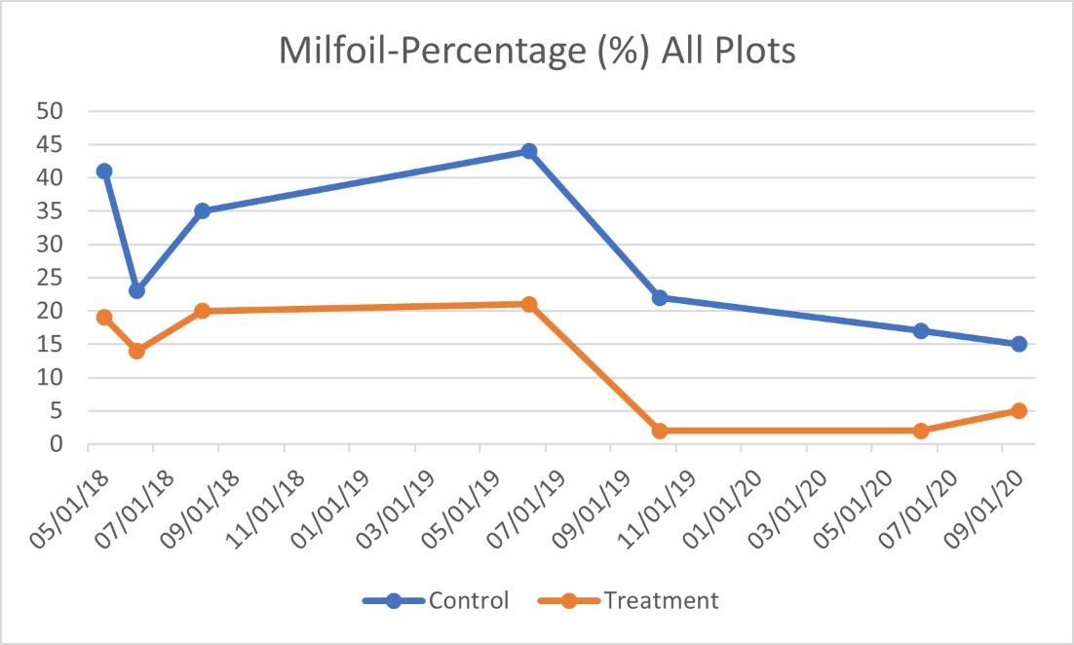
Averaged Milfoil Percentage in Treatment Plots compared with Control Plots

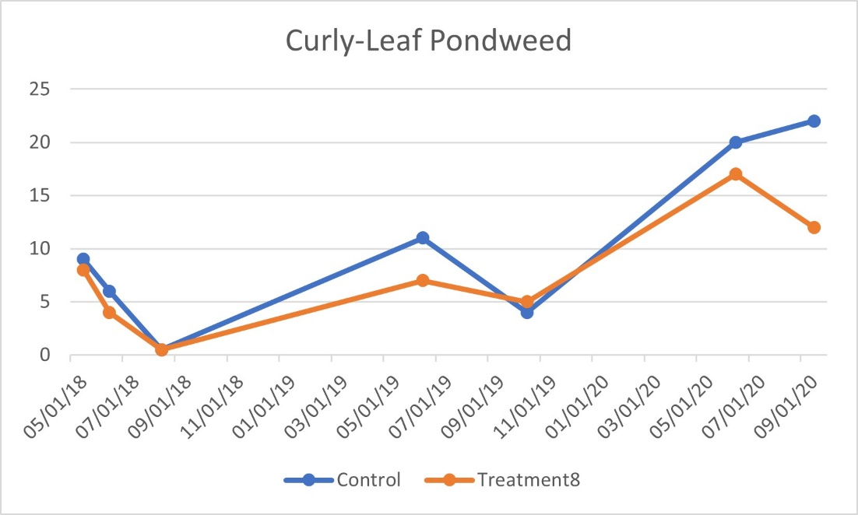
Averaged Curly-Leaf Pondweed Percentage in Treatment Plots compared
with Control plots. Note that Diquat treatment ended at the point marked
09/01/2018 and no further treatment of this species was conducted.

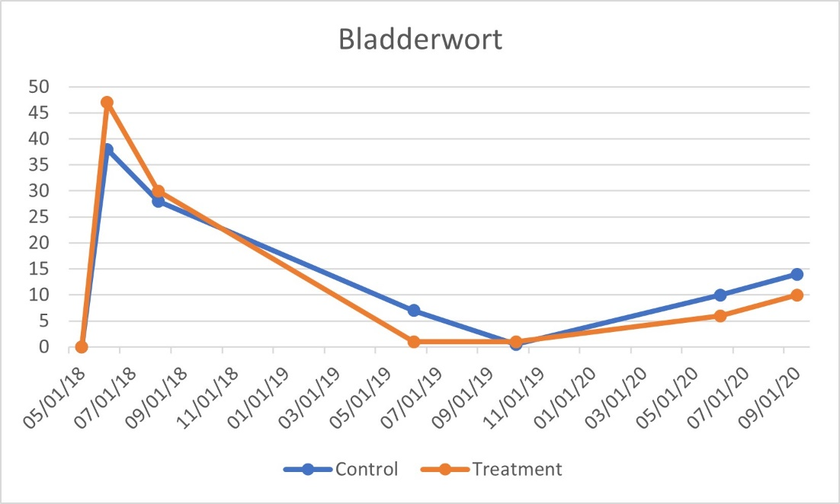
Averaged Bladderwort Percentage in Treatment Plots compared
with Control plots. Note that Diquat treatment ended at the point marked
09/01/2018 and no further treatment of this species was conducted.

See Table of herbicide results. Could not copy it into this document so it is provided separately. File name: 2-B1-B3-tbl-Herbicide-Results-2018-2020
Post Survey Observations – What FLP has Learned
Effectiveness of Control of Invasives. Results from the annual surveys show that herbicide is effective in controlling aquatic weeds in Leverett Pond. Use of Diquat worked well with Bladderwort and Curly-Leaf Pondweed, but had only a slight positive effect on milfoil. ProcellaCOR was applied after 6/26/2019 to control milfoil and did so very well. ProcellaCOR has been shown in other lakes and ponds to last longer than other herbicides. Possibly up to three years (or more). At this writing (2021) milfoil regrowth appears to be returning but is still limited. This is in contrast with other herbicides used on Leverett Pond, which were effective for about one year.
Control Plot Issues. Results from control plots, many of which are located 100 feet lakeward from the center of an adjacent treatment area (treatment plot) show a slight effect from herbicide treatment. Volume of invasive species is considerably higher in the control plots than in treatment plots. However, averaging all control plots shows that there is a relationship with treatment in the treatment plots. Increases and decreases in invasive volume in the treatment plots are also evident in the control plots, but are minor. The location of a control plot that is completely unaffected by the treatment should be farther away (an additional 100 feet) from the test area. FLP will discuss this change with the LCC. As currently designed the test locations for the control plots do not take into consideration that the proximity of the “outside” treatment transect by the application boat. This is closer to the control plot than originally considered. FLP discussed this issue with Dominic Meringolo of Solitude Lake Management and was told that it is not unusual for low-level drift of the dissipating herbicide to effect targeted plants up to about 50 feet distant. No effect on non-invasive plants was observed. The effect on the targeted species within an individual control plot was not observable in the field, but was revealed in the trend during analysis. This said, while trends evident in the treatment areas also occur at much lower levels in the control plots when both are averaged, the volume of the invasive plants is much higher in control plots.
During the 2019 survey, a very dense area of milfoil had grown between the treatment areas of W05-T and W06-T and the control plots W05-C and W05-C. A large number of milfoil “floaters” (milfoil fragments) was floating into the adjacent treatment area, so this area was treated with ProcellaCOR with the “outside” transect of the applicator boat. Control of milfoil in this area was successful and the floating weed fragments eliminated. However, the treatment was close enough to the two control plots to substantially reduce milfoil at their locations as well. FLP will decide on how to include these two plots in the analysis in future surveys.
New Infestations. New infestations of invasive plants can occur in the Pond such as the dense milfoil area that was discovered at the north end of the Public Access boating channel. Newly observed invasive plants (Naiads and Waterweed) were found in three locations in 2020. Lake-wide surveys in the spring will attempt to identify others. These will be added as control plots to the survey plan. It is also highly recommended that the area at the Public Access channel be treated with ProcellaCOR as soon as possible. This area is passed through by boats daily in the warm months, some of which are power-boats, have electric motors or use paddles. These activities break up the plants and spread the infestation. Waterfowl contribute to this. The opportunity to spread milfoil farther into the Pond is very high in this area.
Recommendations. For upcoming surveys FLP will add more control plots out 100 feet or more, while continuing to monitor the original control plots. Control plots will also be added to new infestations as needed.
During surveys, occasionally some areas are darkened and turbid and can obscure observation of weeds. This is usually caused by pollen rain in the spring and leaf fall in autumn. FLP has been using an “Aqua Scope” to see below the surface in these cases, which is helpful. In some cases this will require the use of a “drag rake.” The drag rake is the metal end of a garden rake with 12 inches of handle that is attached to a rope. The rake is dragged on the bottom and the contents brought aboard the boat for identification. Weeds are bagged for proper disposal. This technique makes it difficult to arrive at percentages, but is effective for presence/absence.
Seasonal timing of surveys has been shown to be important. Spring surveys should always precede treatment as presently conducted. If no treatment is planned, the survey should take place no later than in June. The post-treatment or “end of-season” survey should take place in September. From observations in the recent survey, October can be a month where an early frost or cold snap can affect the percentage of invasive plants like bladderwort. Milfoil appears to be unaffected.
Now that a two-year base of data has been compiled a comparison from year to year is possible. Each year, the FLP will provide the LCC with a comparative report.
FLP has recently purchased a new Dissolved Oxygen meter and will establish some test stations on the Pond for background data. This will be especially useful in areas infested with invasive weeds, and beneath areas of floating-leaf vegetation which are excessively shaded and dissolved oxygen is low. pH tests may also be done.

