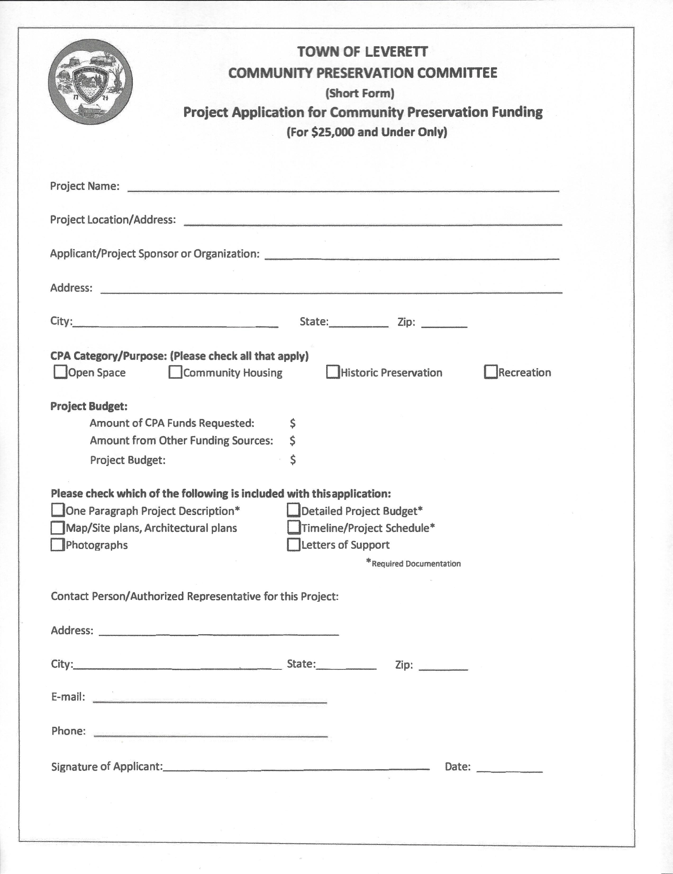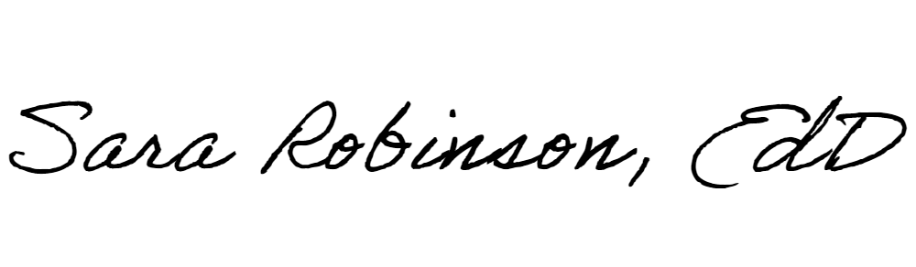

Moores Corner Schoolhouse Envelope Rehabilitation Project

230 N. Leverett Road, Leverett, MA 01054

Leverett Historical Society (LHS)

PO Box 57

Leverett MA 01054

X

24,500

0

24,500

x x

x

x

Sara Robinson, President LHS

77 Jackson Hill Road

Leverett MA 01054

[sarar@umass.edu](mailto:sarar@umass.edu)

413-367-2039 (h) 413-800-2739 (mobile)

10-1-2023

1

Project Description:

This project is designed to rehabilitate the exterior envelope of the Moores Corner Schoolhouse. The included photographs depict the condition of the exterior walls with the front, east and west sides having clapboard siding and the rear having shiplap siding. A protected exterior surface, that would be achieved through surface preparation, painting, and caulking, would prevent water from penetrating the clapboard siding and compromising the building components. The funds requested would be used to retain an architectural historian to oversee the work that will involve extensive prep work, potential remediation work and application of a waterborne bonding primer and a finish coat. Some degree of chalking may also be necessary. Vapor-barrier paints provide an effective moisture barrier.

The building dates to 1810. On May 3, 1968, the Town of Leverett deeded the ‘land in said Leverett, known as Moore Corner, together with the buildings thereon known as the “Moores Corner Schoolhouse by the town, as the town had no use for the building. Over the decades dedicated volunteers of LHS have stepped up to preserve and maintain the schoolhouse, gather, organize archival materials, and fundraise, “collect, hold, and preserve the historical records of the Town of Leverett”. To the people involved and to the pubic which have participated in the many programs or just visited the Schoolhouse, this has been a worthwhile endeavor. The Moores Corner Schoolhouse is one of the few one room schoolhouse in the state and the only one of ten in Leverett which has not been converted to a home or business or been demolished.

Budget:

The requested amount of $24,500 is an order of magnitude planning estimate provided by a Registered Engineer and former Massachusetts licensed construction supervisor Donald Robinson, PhD. The cedar clapboard siding is nailed high which results in the lower portion of the clapboard to lift. Securing the lower half of the siding will also be addressed. Unfortunately, a more specific project budget was not available at the time of submittal. We have reached out to local craftsmen Dave Noonan, Steve Striebel, Charles Abbott, and Matt Abbott for proposals. It is also our intent to engage the services of an Architectural Historian or equivalent preservationist to oversee the work. As soon as the more specific estimates are available, they will be submitted to the CPC and the requested amount adjusted accordingly not to exceed the maximum allowable under the short form.

Timeline:

The preferred time of year to complete this work of this nature is in early spring or summer. If approved at Town Meeting it is intended that the project will be initiated soon thereafter in 2024.

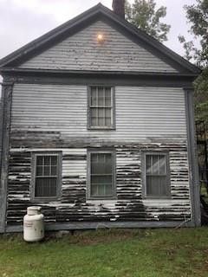

*Figure 1 East Elevation*

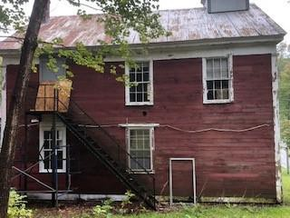

*Figure 2 Rear Elevation*

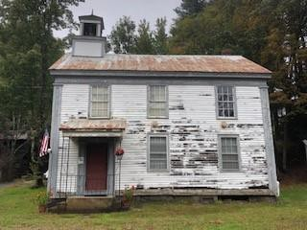

*Figure 3 Front Elevation*

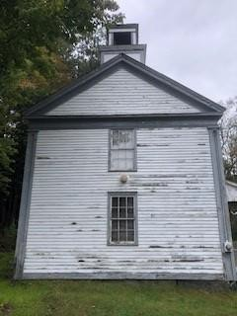

*Figure 4 West Elevation*

Quotes for MCSH rehabilitation of exterior:

John Moore Designs

785 Wendell Rd.

Shutesbury MA 01072

Good Morning Julia,

I looked at the Moores Corner School house it really needs :

1.Power Washing

2. Scraping and sanding clapboards and Trim

3.maybe a lift to do the cupula

4.Full mad Dog prime

5.2-coats latex finish

6.the back could be solid latex stain red

7.windows need scraping,glazing,priming,painting

8.Does the building have lead paint? If it does you have to do lead-safe practice or be fined a lot of money

My work done this way lasts 15-20years and this School House could be a **$20,000.00** job.

John

*Work Estimate*

December 15, 2023

Moore’s Corner School - Leverett Historical Society Town of Leverett 230 N. Leverett Rd.

Leverett, MA 01054

Thank you for the opportunity to provide a quote for the exterior painting work at the Moore’s Corner School in Leverett. If you find this quote to be agreeable, we will work together to complete this job accordingly.

Quote includes:

* All labor and materials – recommendation is Benjamin Moore products o All appropriate preparations included but not limited to:

§▪ Pressure washing where necessary

§▪ Scraping and sanding of all loose paint material

§▪ Securing of loose boards/siding

§▪ Caulking/filling wherever needed

§▪ Window glazing where required o Full priming of all surfaces o Two coat of finish paint on all areas.

* All necessary cleanup including disposal of lead paint material o *All change orders and carpentry - $80/hr + material, requires owner approval

* **Labor - $22,000**
* **Paint/Materials - $2,500**
* **Quote Total - $24,500**

Paul Shepard • (413) 822-2198 • shepref@aol.com Josh Shepard • (413) 449-4784 • joshepard@gmail.com

**Maintenance Program for Moores Corner Schoolhouse/Museum**, a LHS owned building at 230 North Leverett Road, Leverett, MA MCSH is in the historic district of the village of Moores Corner.

The System Replacement Plan (SRP) that is underway by grants from Mass Cultural Council and matching grantor, Leverett’s CPC, provides an assessment of the Moores Corner Schoolhouse giving documentation of its needs and **a maintenance schedule plan** for the implemented rehabilitations.

As stated in the “Description of Matching Funding and Mass Cultural Council Certification”:

**Non-profit Financial Fund (NFF) will condust a 1-hour meeting by phone or in person to discuss the SRP findings and follow-up terms for LHS. The basis of the discussion will be a report of SRP and the interactive tool (the “SRP Planning Tool”) which can be used for planning repair and replacement scenarios.**

In anticipation of the SRP report, it is obvious that the envelope of the building needs attention. Eric Gradoia, a building conservator and architectural historian with thirty years of experience studying and assessing historic buildings and recently been the Director of Historic Preservation at Historic Deerfield, visited the Moores Corner Schoolhouse and stated that the clapboard siding be resecured to sheathing as needed, caulked, scraped, primed, and painted with a high-quality paint as soon as possible. That observation was in October 2023.

Therefore, we are seeking **funds for the rehabilitation of the Schoolhouse’s envelope**. Eric mentioned that a building should be repainted about every 10 years. Moores Corner Schoolhouse is long overdue.

The maintenance program will follow the recommendations of the SRP that is forthcoming. (See quote of agreement above.)

Grounds care: Overseen by volunteer William Stratford

Checking on building and making necessary small repairs: Dennis Lombardi, accomplished carpenter (in-kind)

Yearly volunteer work day for deep cleaning and light repairs

Regular inspections: Leverett Historical Commission makes a yearly review because of historical restrictions put in place because of a CPC grant.

Knowing the approximate lifespan of roofs and other building components (SRP Plan) and anticipating repairs before water leaks in or paint starts to peel, funds will be set aside for anticipated large repairs.

However, even with the best maintenance plan, the unexpected happens. The insurance is up-to-date and money funds will be set aside for such occurrences.

LHS is in the process of obtaining funds through a town wide fund-raising campaign, grants, sale of books, bank donations, family trusts, private donations, events, and increased membership base.

Volunteers are and have been a sustaining attribute for aiding the Moores Corner Schoolhouse/Museum.

Once rehabilitation is completed, anticipated maintenance costs are low, so funds can be sought and set aside for a few years. Then as repairs come due, funds are available and additional funds can be sought to meet the increase in costs of maintenance and repair as the years advance.

The chart below reflects the projected annual maintenance net fund balance after fund raising efforts and anticipated expenditures.

The Moores Corner Schoolhouse/Museum is a valued and historic building in Leverett. It is the only one of ten one-room schoolhouses that remains as a schoolhouse structure. Since Covid many well attended programs have been presented (seasonally). A mock-classroom is set up for visitors to experience the educational setting prior to the consolidated school in 1950. The building houses and displays Leverett’s artifacts, photographs, and documents that are important to knowing the Town’s history, education, culture, and socialization. Rehabilitation and maintenance of the building is vital for an inviting, safe, and historical Town building.

Further budget information for CPC Application 2024:

Leverett Historical Society submitted other grants to rehabilitate the Moores Corner Schoolhouse.

|  |  |  |
| --- | --- | --- |
| 1772 Foundation Preservation MA | $10,000 | Submitted |
| MCC Capital Grant (June 2024) | $30,500 | Submitted |
| CSAA Grant for Disaster Relief | $1,000 | Submitted |

The 1771 Foundation Preservation MA grant is a matching grant that the CPC grant, if awarded, would be a match for it. Thus, any unforeseen repairs in the envelope rehabilitation project would be supported in that grant.

LHS contacted our local Massachusetts representatives, but they are unable to support the CPC application in that it is a governmental grant.

On Wed, Feb 21, 2024 at 9:25 AM Kagan, Robert <[rkagan@nff.org](mailto:rkagan@nff.org)> wrote:

Hi Sara

Thank you so much for your patience as this all worked with the system. I can now confirm we’ve received your matching payment and shared the intake materials with our engineering consultant, and we are ready to proceed in scheduling the SRP intro call and site visit.

In order to move your Systems Replacement Plan (SRP) assessment forward, I’d like to introduce you to the SRP engineer, Joseph Olive, who will be conducting the building inspection for The Leverett Historical Society. Once the date is set between you and Joe for a site visit, the NFF team will follow-up to schedule an intro call with this entire group prior to the site visit.

I’ve also cc’ed Sarah Stricklin and LaShawn Taylor, the NFF Consultants who will join this intro call and present the SRP Assessment Tool and Summary deck upon completion of the site visit.

Please feel free to reach out to our team if you have any questions at all during this process.

Best,

**Robert Kagan**  
Director, Consulting  
He/Him/His  
  
Nonprofit Finance Fund  
89 South Street, Suite 402

Boston, MA 02111

617.204.9772 ext. 310

[nff.org](https://nam10.safelinks.protection.outlook.com/?url=https%3A%2F%2Fnff.org%2F&data=05%7C02%7Csarar%40umass.edu%7C41125e039bd546693a0308dc32f45974%7C7bd08b0b33954dc194bbd0b2e56a497f%7C0%7C0%7C638441272291100770%7CUnknown%7CTWFpbGZsb3d8eyJWIjoiMC4wLjAwMDAiLCJQIjoiV2luMzIiLCJBTiI6Ik1haWwiLCJXVCI6Mn0%3D%7C0%7C%7C%7C&sdata=jnYJ4mwCz4GC3ramupjgsQA7MrZHBaMF6jVycNTrjFk%3D&reserved=0)

Sara,

March 5th will work. IF that is okay with everyone else I will send an invite for the 5th. Thank you for the quick response.

Joe

**Joseph E. Olive (Sr)** |President

201 West Broadway, Unit 216, Port Jefferson, NY 11777

Office 631-828-6671   |   Cell 914-882-4871

[joesr@olivebranchconsultingltd.com](mailto:joesr@olivebranchconsultingltd.com)